|  |  |
| --- | --- |
| Course Name | ITD 2313 – Script Programming |
| Instructor | Put instruction name here |
| Student Name | Put student name here |
| Due date | Put assignment due date here |
| Grade | Put grade earned here |
| Grading Comments | Put instructor comments here |

### Page 42

1. Half way down the page is your first set of code examples to type in.  Notice the usages for the singe quotes and the double quotes.
2. Near the bottom is the second set of example code on this page
3. Screen shot the results and place it into your submission document.  If you are getting errors on any of the example code when there authors give you what the output should look like, you need to be checking to see what you did incorrectly and correct it.  Do not just constantly turn in code examples with lots of errors showing.  Each example should be very close if not a match to what is shown in the text.

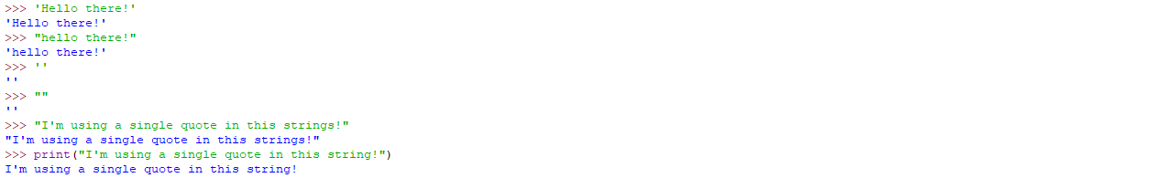

### Page 43

1. Near the top is your first set of example code to type in and put into a screen shot
2. Just a little above the half way point on the page is the next set of example code the needs to be in the screen shot for the text book page
3. At the very bottom of the page is the third and final example set of code for this page in the text

PIECE OF ADVICE: You should note table 2-3 on the page and the use of escape sequences.    You should experiment around with the various escape sequences and see how they work even though there is not example code assigned for it.

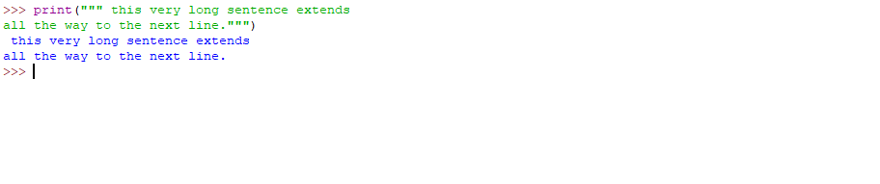

## String Concatenation

### Page 44

1. There is only one small set of example code on the page and it is near the top of the page.

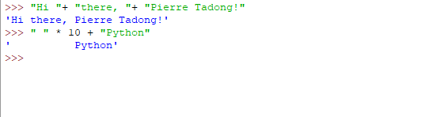

## Variables and the Assignment Statement

### Page 45

1. This is a rare instance where the example code actually starts on the previous page and ends on this page.  On the very bottom of page 44 is where the example code starts that ends at the very top of page 45.  Be sure to replace the author's name with your own name when doing the example.  You will need to take a screen shot of this step for your submission.
2. In the subsection on page 45 dealing with Comments, you will see a large comment block.  You will not need to grab a screen shot of the large comment block example code there.
3. On the very bottom of the page, there is an example code line where they show how to do an inline comment.  You will not need to screen shot this line of example code either for your submission.

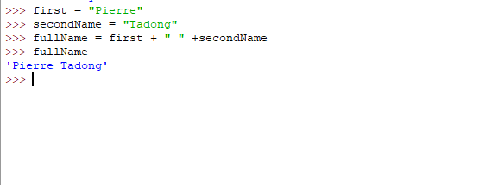

## Arithmetic Expressions

### Page 51

1. This is an unusual one.  The table 2-7 is the list of Arithmetic expressions you are to enter and capture in screenshots.  There are 10 Expressions in the left hand column of the table.  Do all 10 for your screen shots.

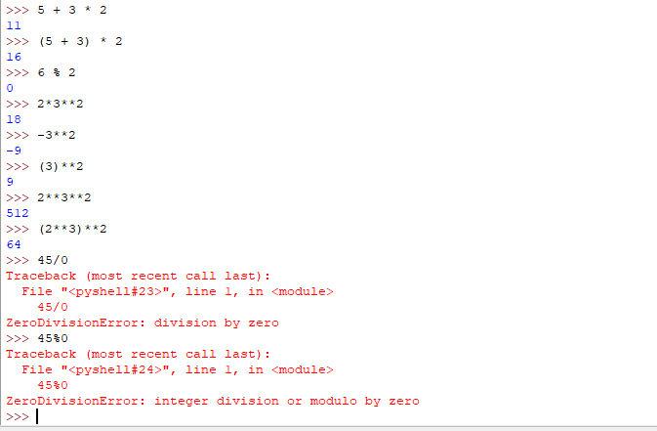

### Page 52

1. At the top is the first example code that will need to be entered for this page
2. In the middle is a single line of example code which is the 2nd one on the page
3. About 3/4 the way down is the third example code set for the page
4. At the very bottom is the 4th and final code set for the page

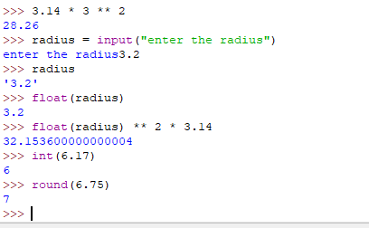

## Mixed-Mode Arithmetic and Type Conversions

### Page 53

1. About 1/2 way down is your first code example.  It is to be typed in that way to show the error case if causes.  Do not correct the code to make the error go away for this example code item
2. A little past the half way point on the page is the next example code item for the page

You have made it to the end of the assignment. The screen shots you took should be in the Submission document. All coding was done in the interactive model for this exercise so there is no code to submit for this exercise. Turning in just the submission document is acceptable for this assignment. Future assignments may require that you zip files together into a zip file for submission.

